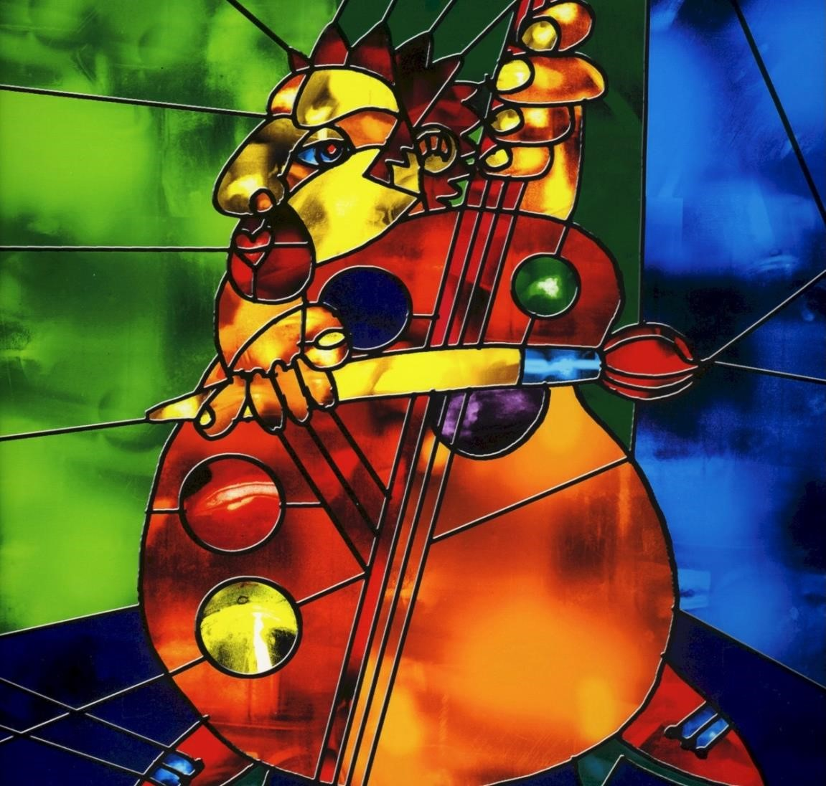
COVER IMAGE PLACEHOLDER: Stained-glass artwork from Figments of My Imagination.

Dedication
For Beatriz.

Upstairs at the Van Dyke

The Memoir of Dr. Don Wilner

Table of Contents (with page numbers)
Chapter One — The Van Dyke Years
Chapter Two — The Bandstand Wars
Chapter Three — Legends in a Small Room
Chapter Four — The Misbehavior Files
Chapter Five — The Business of Jazz
Chapter Six — The Brazilian Connection
Chapter Seven — The Legacy
Appendix — Press & Testimonials
Appendix — Photo Index
About the Author

Chapter One — The Van Dyke Years
“Bassist Don Wilner alone is worth a trip to Miami Beach.” — Yahoo Travel Guide
When I first set foot in the Van Dyke Café, I wasn’t thinking about running a jazz club. I was just called as a sideman — me and a piano player, nothing fancy. I played there a few weeks before I realized one of the owners, Jeff Davis, had been a classmate of mine back at Rockland Community College. Funny how life circles back like that.
Not long after, Jeff and his partner, Mark Soyka, called me in for a meeting. They asked if I’d like to take over the music. Just like that, I went from sideman to music director. I started booking the club seven nights a week, upgrading the lights and the sound system, making sure the place looked and sounded the way real jazz should.
Why did I say yes? Because it was an opportunity to play and present music exactly the way I wanted to. By then, I’d been through it all — jazz, classical, Broadway pits, you name it. I had just finished my doctorate and could have gone into teaching, but playing was natural for me. My bachelor’s was in classical and jazz, my master’s in jazz composition and electronics, and my doctorate in performance. Everything in my training pointed to this moment. The Van Dyke gave me a platform to put it all into practice.
There were incredible nights on that stage, but one stands above the rest: when Toots Thielemans came to play. Mike Renzi was on piano that night. The place was packed — so full that even the stairway was jammed shoulder to shoulder. Normally, the room was noisy. Not that night. You could’ve heard a pin drop. And when Toots played “If You Go Away,” the whole house wept. I’ll never forget the sight of tears streaming down the staircase.
As a bassist, I loved playing there because I was in complete control of the sound. I unplugged from the soundboard and ran everything myself. My philosophy was simple: I wanted the sound system to reproduce exactly what I was hearing on stage — no more, no less. We even piped it downstairs and outside so people could hear the same balance. That kind of honesty made all the difference.
But it wasn’t all smooth. This was Miami Beach, not exactly filled with seasoned jazz audiences. Plenty of tourists treated it like background music, and I fought constant battles to protect the sanctity of the room. In the early days, one group actually sat in the front row with a ghetto blaster, playing it at us and telling us this was real music and what we played was garbage. I had them thrown out. More than once I lost my temper. I remember shouting “SHHHH!” into the mic so loud the manager came running upstairs, thinking there’d been a fight. Sometimes I turned the tables with sarcasm — complimenting noisy crowds on how “well” they knew how to listen. It was a war, but one worth fighting.
The audiences were mixed. In the summers, when the tourists left, the locals came in — the ones who really wanted to hear the music. That was when the room felt best. Many of the University of Miami jazz faculty hardly ever came, which disappointed me, but celebrities did wander in. Joe Williams once came by and sat in. Lots of local musicians wanted to sit in too, but I only let the best do it — the ones who understood what was happening musically. That didn’t win me any popularity contests, but it kept the standard high.
People told me the Van Dyke was the number one jazz club in South Florida. I wasn’t thinking about that at the time. I was just doing my best to put the right musicians on that stage and keep the sound honest. Apparently, that was enough.
The club gave me plenty. I used the room — and the owners’ money — to record seven CDs of my own, often with big‑name players I had booked into the club. It pushed me to play at the highest level of my life. The frustrations were many — especially with managers who thought they knew music better than I did and who’d blast garbage music over the system during set breaks. But the rewards outweighed the grief.
And then there was the greatest gift of all: I met my wife there. I was looking for a new Brazilian singer — the one I had wasn’t working out. A singer named Beatriz Malnic came in to audition. She sang in tune, knew her keys, knew how to handle intros and endings. Her delivery was fantastic. Her stage presence needed a little shaping, but she learned that working with me. I wasn’t looking for a wife, but that’s what I found.
In the end, the Van Dyke outlasted any other jazz club around. Plenty of places called themselves jazz clubs, but they weren’t presenting serious music night after night. The Van Dyke was the real thing. No bullshit.
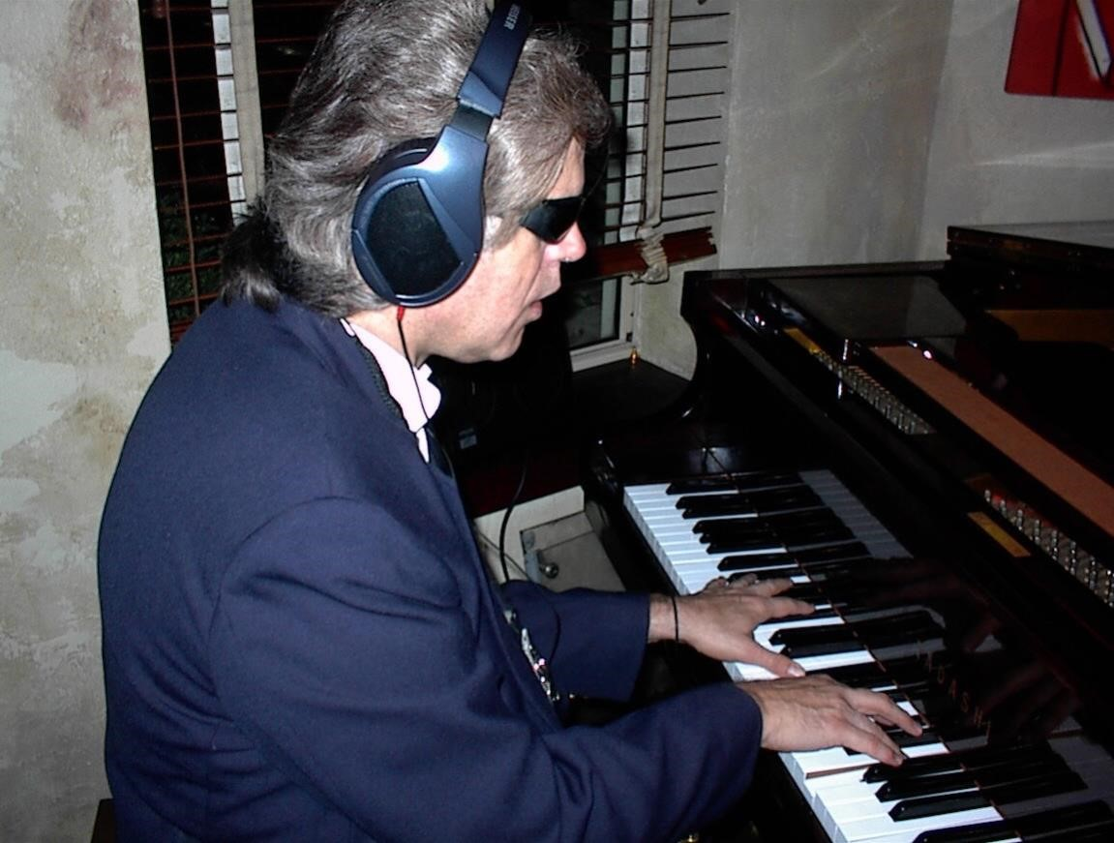
[Photo: Mike Gerber at the piano.]
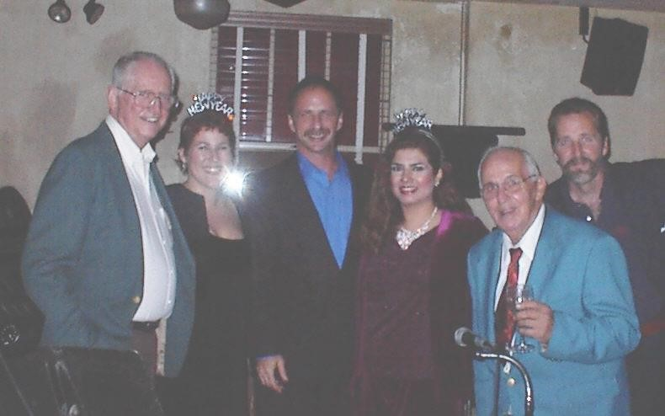
[Photo: New Year’s Eve 1999 — Eddie Higgins (piano), Wendy Pedersen (vc),Don Wilner (bass), Gilly Di Benedetto (sax).]

Chapter Two — The Bandstand Wars
“The Van Dyke has become a proving ground for Miami’s top players — and the kind of place where the music can erupt into battle at any moment.” — Miami New Times
The Van Dyke was a small room, and when it was crowded, the audience was right up against the bandstand. That closeness could create magic — or chaos.
One weekend Jerry Brown — a great drummer who had worked with Stevie Wonder and Diana Ross — was playing with me. This was his chance to stretch out and play jazz in Miami Beach. The place was packed, wall to wall. Then some idiot in the crowd picked up one of Jerry’s drumsticks and started hitting a drum. When I looked back, Jerry had the guy by the throat. That’s how thin the line was between music and madness.
My rule of thumb with sound never changed: if it sounds right on stage, don’t reinvent it out front. That’s why I unplugged from the board, mixed from the bandstand, and sent the same sound downstairs and outside. Honesty over hype — always.
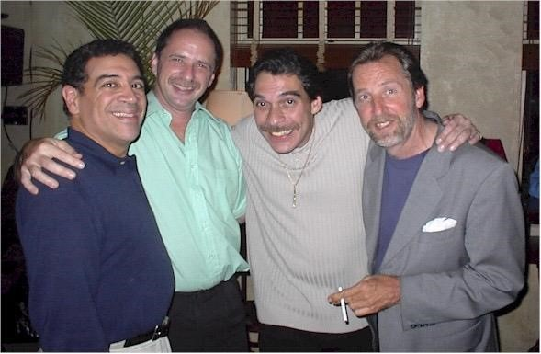
[Photo: Sammy Figueroa (perc), Don Wilner (bass), Dave Valentin (fl), James Martin (dr).]

Chapter Three — Legends in a Small Room
“When he plays in the Van Dyke Café’s upstairs bar, he reveals himself to be the heppest of hepcats… As the Van Dyke’s musical coordinator, he keeps the room humming seven days a week.” — Miami New Times
The room could shrink around a great player like a lens. Toots Thielemans, of course, turned the upstairs into a chapel. Joe Williams wandered in one night and reminded everyone what phrasing really means.
Another night, Dr. Lonnie Smith floated in wearing his trademark headdress and sat at the organ. Suddenly the room had church in it — grease and grace at the same time. That’s the magic of a small room: legends sound bigger, not smaller.
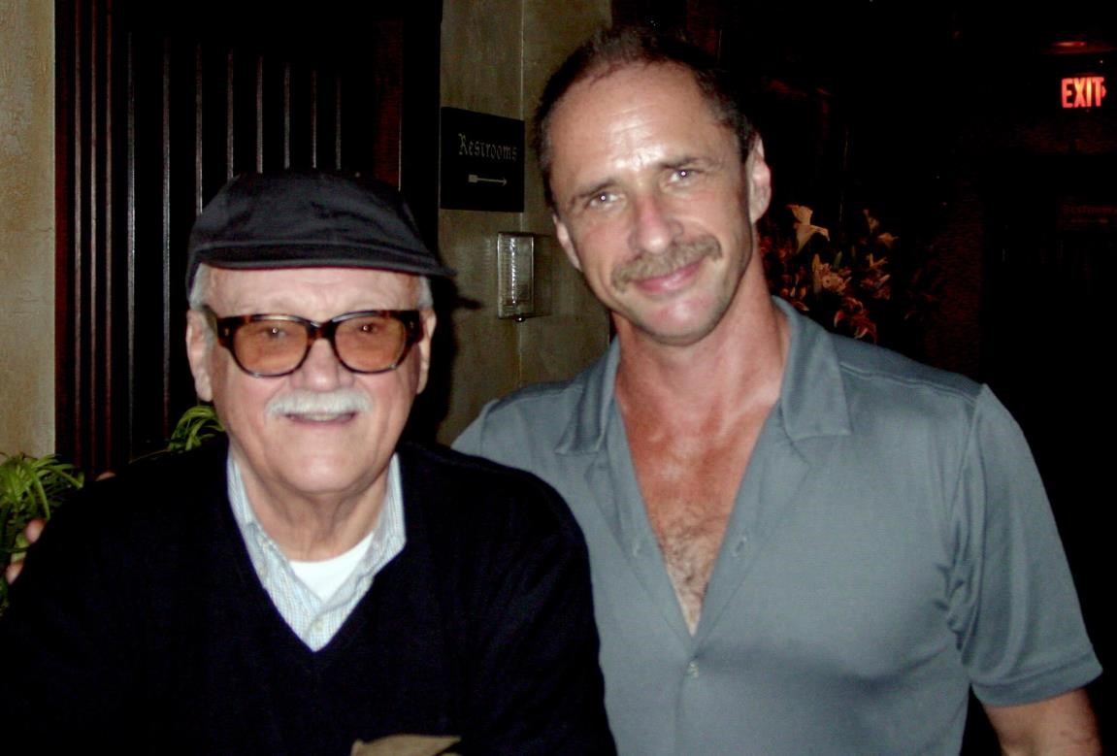
[Photo: Toots Thielemans with Don Wilner.]
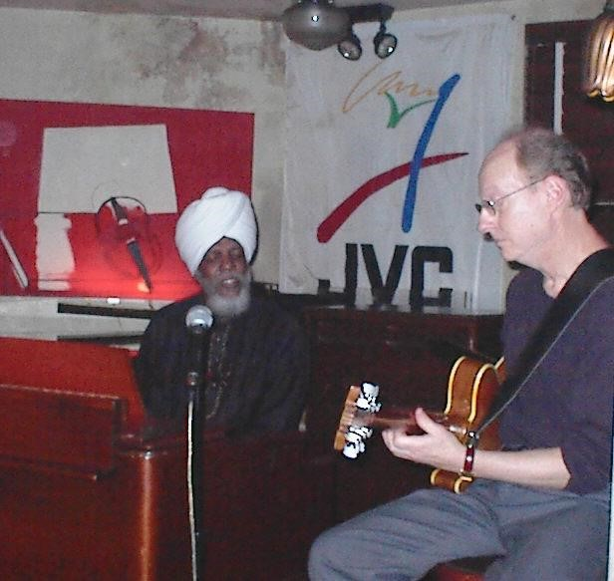
[Photo: Dr. Lonnie Smith(org), with Bob Devo (gt).]

Chapter Four — The Misbehavior Files
“The Van Dyke sustains a weekly jazz/blues format because Don Wilner, an old‑school South Florida jazzman, books the talent.” — Miami New Times
Running the music at the Van Dyke meant I saw the best of jazz — and some of the worst behavior that came with it. Musicians, audiences, even managers… everyone had their moments. Some I’ll never forget.
- The Drumstick Incident — Jerry Brown and the audience member who learned the hard way not to touch a drummer’s kit.
- Mike Orta’s Sidewalk Fireworks — My number‑one pianist for years was brilliant and complicated. Unhappily married, chasing singers. One night his wife came in disguised, waited till the set ended, and confronted Mike and his girlfriend on the sidewalk. Fireworks in front of the crowd.
- Turk Mauro and the Stolen Mics — Old‑school tenor, cash‑only guy. After a drunk set, he was told a new system meant weekly checks. He grabbed every microphone in the room and held them hostage until I brought cash. We nearly came to blows. Mike Orta brokered the return at a neutral spot.
- Sinatra Tuesdays — Tony Fernandez was a handsome kid with a fine voice, loved by the owner’s right‑hand man Ryan and his large crowd. He sang the records, exactly. He also rotated girlfriends weekly. One Tuesday, last week’s girlfriend arrived drunk, saw the new one, and began stripping in front of Tony mid‑song. I stopped the band and told the pianist, “Play ‘The Stripper.’ A gentleman wouldn’t let her do this without music.” The floor manager sprinted upstairs and dragged her out.
- Walt Andrus, Almost Live — The Sinatra ringer from the Tommy Dorsey Orchestra loved the Van Dyke. I planned a live recording. The GM warned me: “I love Walt, but not if he’s drunk.” I told Walt he couldn’t drink in the club, so he drank before he came. By the first break he could barely stand. He stumbled outside and collapsed into the GM’s arms.
- The Bob Devo Incident — Bob looked like the farmer from American Gothic and spoke about as often. The night after New Year’s, one loud couple sat inches from the bandstand, ignoring the music. I stopped the band to say something. Bob beat me to it: “Why don’t you shut the fuck up?” She stood: “You shut the fuck up.” Chaos. My friend, the GM Frank, said I had to fire Bob. I called him the next day, fired him — and rehired him in the same breath, booking him for the next two weeks. Sometimes that was the truest music we played.
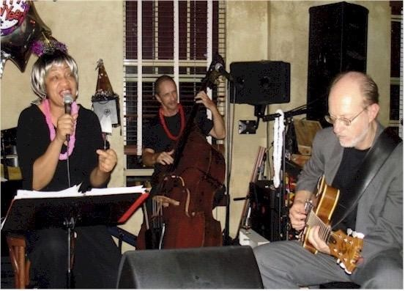
[Photo: Doris Spears (present the night of “The Incident”).]
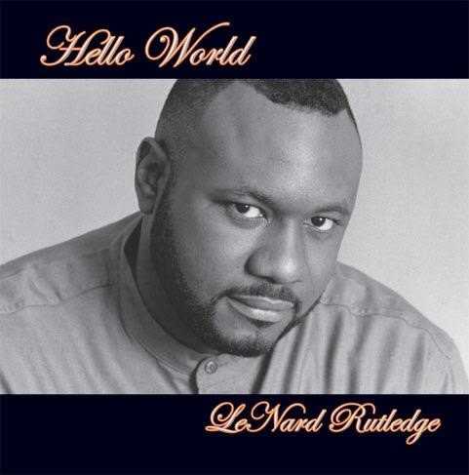
[Photo: Lenard Rutledge, vocalist.]

Chapter Five — The Business of Jazz
“Best Jazz Club in Miami.” — Miami New Times, Best of Miami Issue
Running the music wasn’t just about calling tunes and hiring bands. It was a daily negotiation between art and business. Floor managers fought me over volume, set lengths, and — worst of all — the break music. I’d build a listening room, and they’d fill it with garbage CDs the moment we stepped off stage. Those fights nearly cost me my job more than once.
The audience split down the middle: some paid the cover because they wanted to hear the music; others paid just to rent a chair and talk through the set. I tried diplomacy, humor, shame, and sheer volume. It wore me down, but it also clarified what I believed: jazz deserves a room that listens.
The money game was constant. Musicians wanted cash. Owners wanted checks. Some nights were packed; some nights I paid the band anyway. Still, I turned the business into art whenever I could. I used the club’s reputation — and sometimes the club’s money — to record seven CDs of my own with world‑class players. The Van Dyke was my studio as much as my stage.
I’ll admit it: I lost my temper more than once. I regret that. But the same fire that made me blow up at a manager or a noisy table is the fire that went into my playing. My temper, my passion, my investment — they weren’t separate from the music. They were the music.
[Album cover: Figments of My Imagination.]
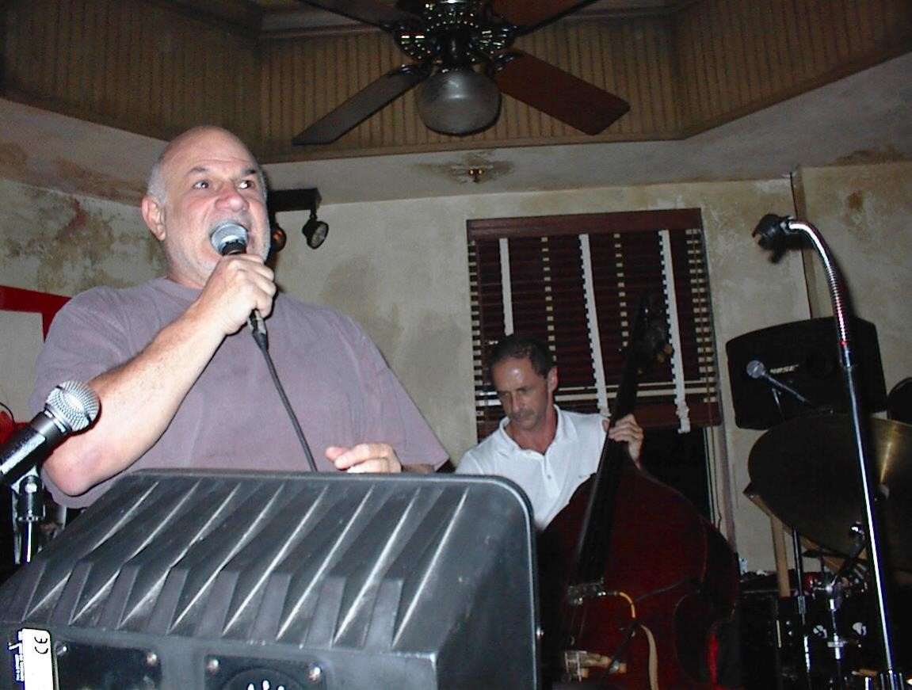
[Photo: Mark Soyka, owner of the Van Dyke Café.]

Chapter Six — The Brazilian Connection
“With the addition of Brazilian nights, the Van Dyke broadened its palette — a blend of samba, bossa, and straight‑ahead that drew new audiences without sacrificing quality.” — Local Press
Brazilian music had always pulled at me — the sway of samba, the quiet ache of bossa, the harmony and the air around the notes. At the Van Dyke I went looking for the right voice.
I already had a Brazilian band, but the singer wasn’t a fit. I auditioned one after another until Beatriz Malnic walked in. She sang in tune, knew her keys, handled intros and endings, and delivered with grace. Stage presence can be learned; musical truth can’t. She had it.
We built Brazilian nights that gave the room a new pulse: bossa nova, samba, MPB. She brought authenticity; I brought arrangements and discipline. The audiences leaned in differently. The music taught me new ways to hear and feel.
What started on stage became a partnership in life. Beatriz and I built not just a band, but a home. That’s one of the great gifts the Van Dyke gave me.
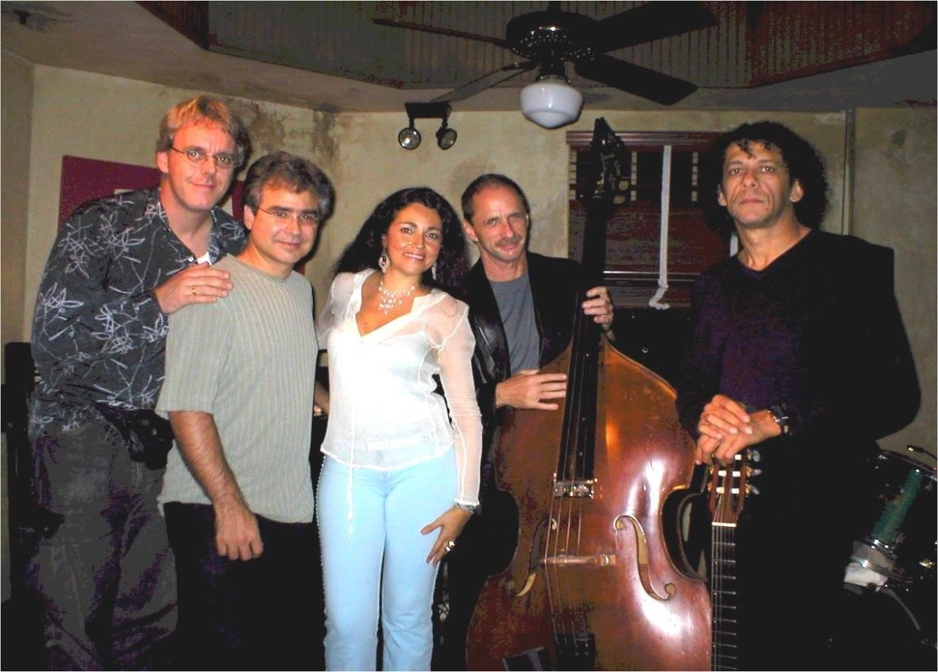
[Photo: Brazilian band — Goetz Kujack (dr), Mike Orta (pno), Rose Max (voc), Don Wilner (b), Ramatis Moraes (gtr).]
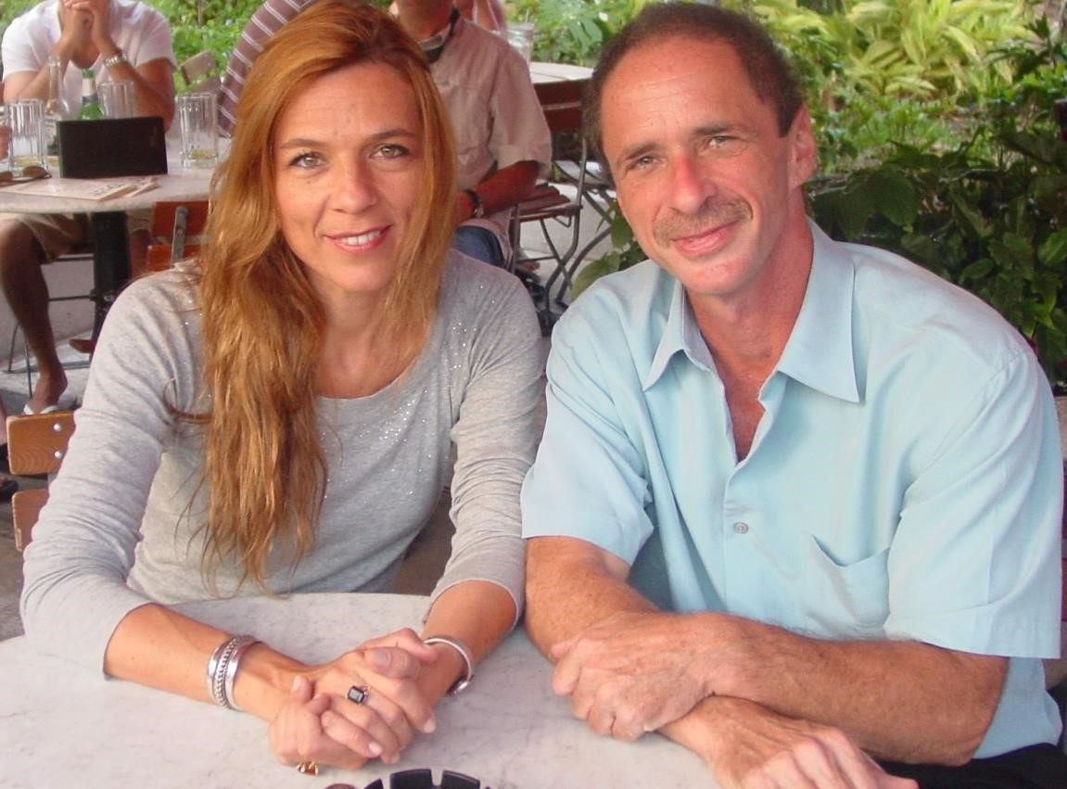
[Photo: Beatriz Malnic and Don Wilner.]
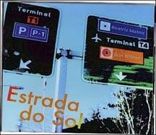
[Album cover: Estrada do Sol.]

Chapter Seven — The Legacy
“The Van Dyke Café, for nearly two decades, was Miami Beach’s premier jazz club — a place where legends and locals met upstairs, every night of the week.” — WLRN Public Media
The Van Dyke Café stood on Lincoln Road for nearly two decades, and during that time it became something bigger than a club. For Miami, it was the place where you could hear serious music seven nights a week. Not background jazz, not cocktail‑hour wallpaper — the real thing.
We weren’t just a local room, either. We hosted the JVC Jazz Festival more than once, and that’s how players like Cedar Walton found their way onto our stage. The room rose to meet them; legends felt even larger in that upstairs space.
For me, the Van Dyke was more than a job. It was my laboratory, my stage, my testing ground, my home. It pushed me to play at the highest level of my life. It gave me seven albums’ worth of chances. It taught me hard lessons about business, temper, and patience. It gave me nights of magic — like the evening Toots Thielemans brought a roomful of strangers to tears. And it gave me Beatriz.
When I think back on those years, I don’t think about being “number one.” I think about the investment I made — emotional, musical, personal. Every note I played, every fight I fought, every night I kept that stage alive, it came from me. That’s who I am. The Van Dyke is gone now, but its sound and spirit live on — in the musicians who played there, in the audiences who listened, and in me.
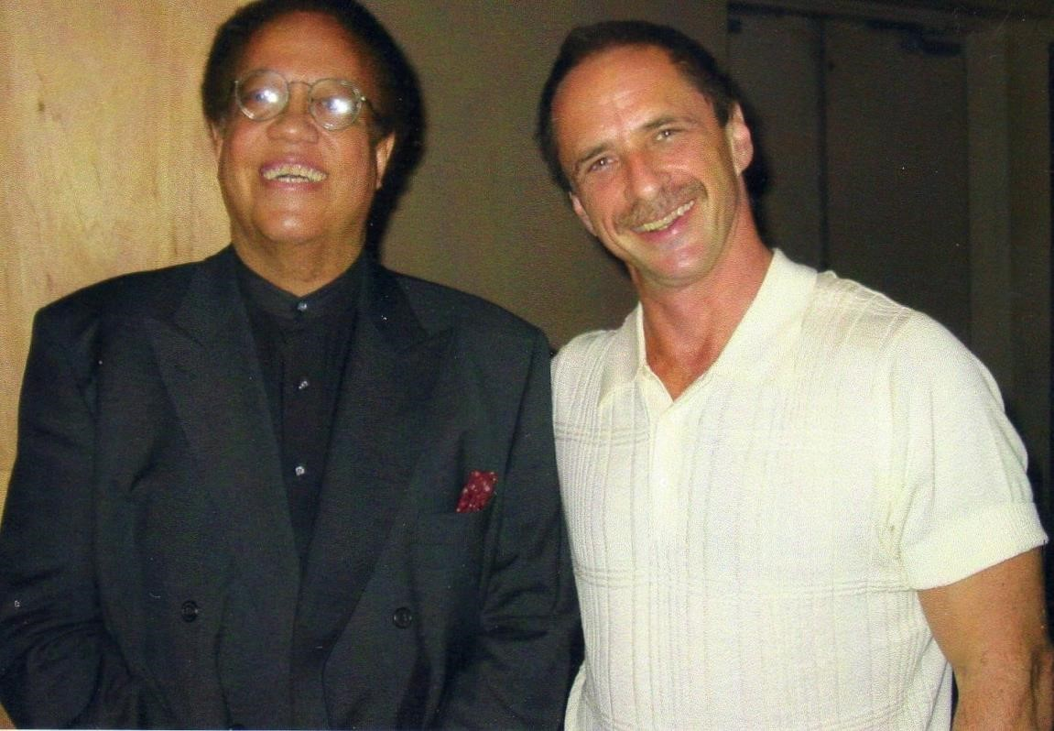
[Photo: Cedar Walton with Don Wilner (JVC Jazz Festival).]
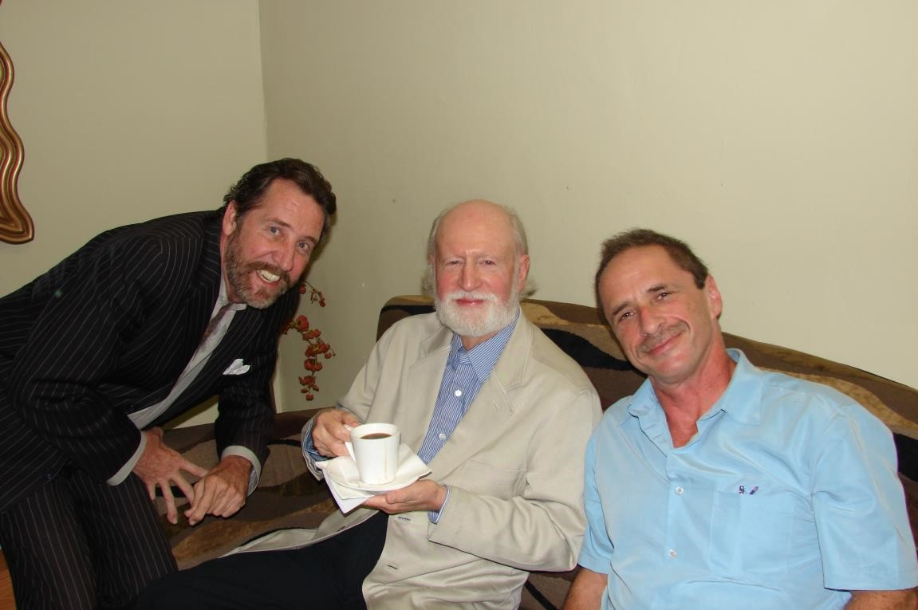
[Photo: James Martin (dr), Mose Allison (center), Don Wilner (b).]
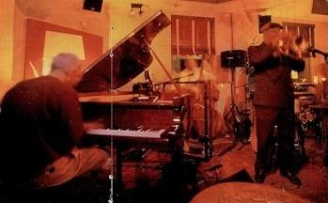
[Photo: Mark Marineau (pn), Don Wilner (b), Pete Minger (flg)
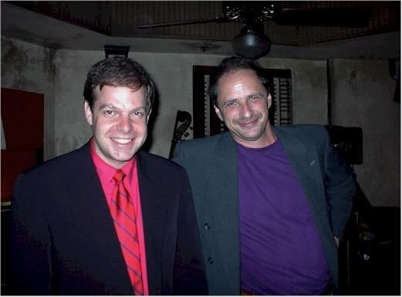
[Photo: Bill Charlap (pn), Don Wilner (b)
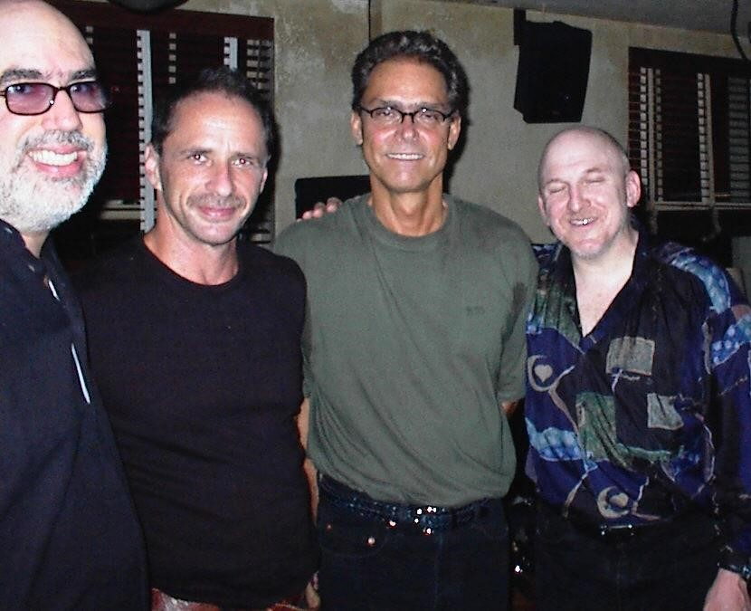
[Photo: Randy Brecker (tpt), Don Wilner (b), Gary Campbell (tn), Adam Nussbaum (dr)]

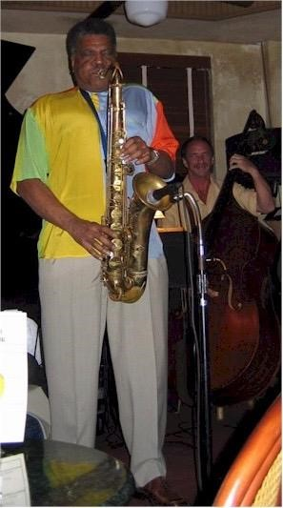
[Photo: George Coleman (tn), Don Wilner (b)]

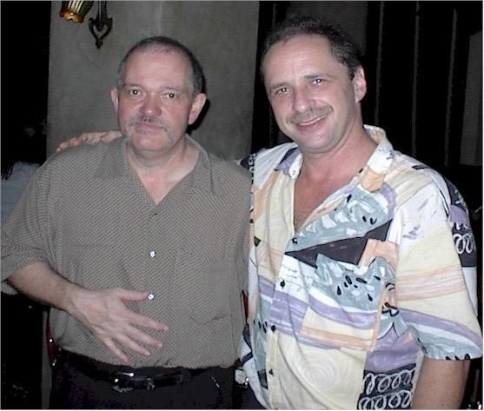
[Photo: John Abercrombie (gt), Don Wilner (b)]
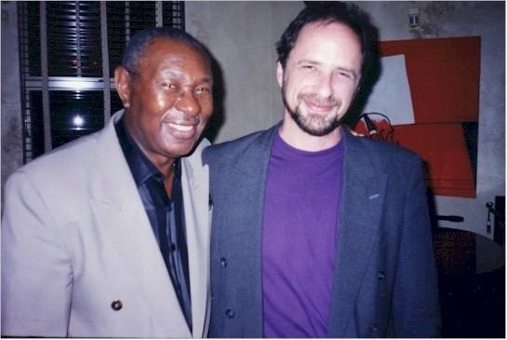
[Photo: Freddie Cole(pn), Don Wilner (b)]
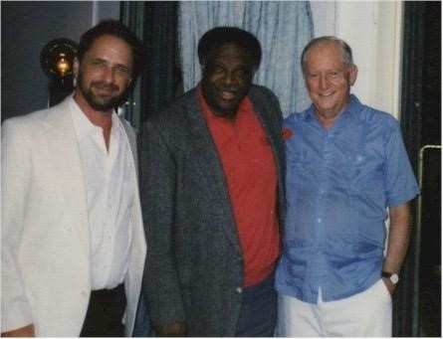
[Photo: Don Wilner (b), Houston Person (tn) Eddie Higgins (pn)]
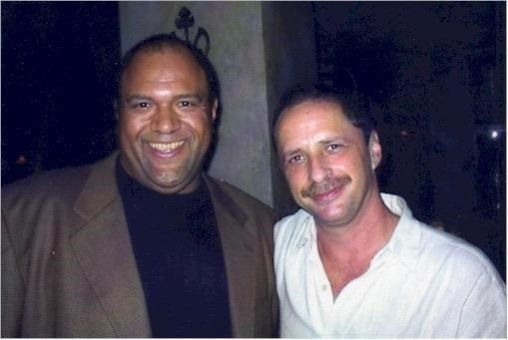
[Photo: Kenny Drew, Jr. (pn),Don Wilner (b)]
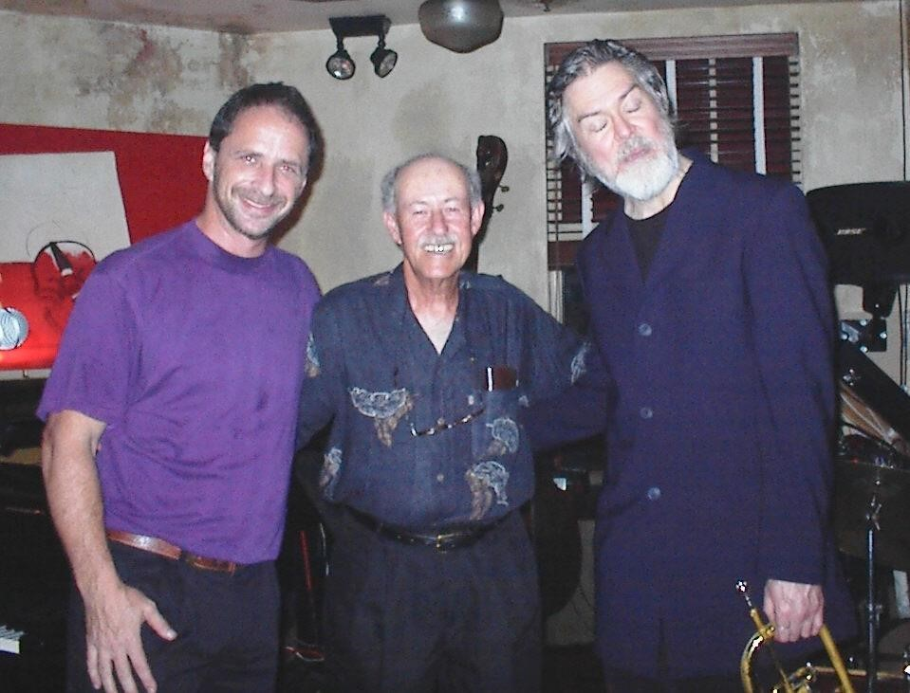
[Photo: Don Wilner (b), Don Freidman (pn), Tom Harrell (tpt)]]

Appendix — Press & Testimonials
“Bassist Don Wilner alone is worth a trip to Miami Beach.” — Yahoo Travel Guide
“When he plays in the Van Dyke Café’s upstairs bar, he reveals himself to be the heppest of hepcats… As the Van Dyke’s musical coordinator, he keeps the room humming seven days a week.” — Miami New Times
“The Van Dyke sustains a weekly jazz/blues format because Don Wilner, an old‑school South
Florida jazzman, books the talent.” — Miami New Times
“Best Jazz Club in Miami.” — Miami New Times, Best of Miami Issue
“With the addition of Brazilian nights, the Van Dyke broadened its palette — a blend of samba, bossa, and straight‑ahead that drew new audiences without sacrificing quality.” — Local Press
“The Van Dyke Café, for nearly two decades, was Miami Beach’s premier jazz club — a place where legends and locals met upstairs, every night of the week.” — WLRN Public Media

Appendix — Photo Index
Mike Gerber at the piano.
New Year’s Eve 1999 — Eddie Higgins (p), Don Wilner (b), Gilly Di Benedetto (ts).
Sammy Figueroa (perc), Don Wilner (b), Dave Valentin (fl), James Martin (dr).
Toots Thielemans (harm) with Don Wilner (b).
Dr. Lonnie Smith (org) with Bob Devoe (gtr).
Doris Spears (voc).
Lenard Rutledge (voc).
Tony Fernandez (voc) — Sinatra Tuesdays.
Album cover: Figments of My Imagination.
Mark Soyka — owner of the Van Dyke Café.
Brazilian band — Goetz Kujack, Mike Orta, Rose Max, Don Wilner, Ramatis Moraes.
Beatriz Malnic & Don Wilner.
Album cover: Estrada do Sol.
Cedar Walton (p) with Don Wilner (b) — JVC Jazz Festival.
James Martin (dr), Mose Allison (voc/p), Don Wilner (b).

About the Author
Dr. Don Wilner is a bassist, composer, and bandleader who has performed across jazz, classical, and Broadway stages. For more than a decade, he was the driving force behind Miami Beach’s Van Dyke Café, presenting world‑class jazz seven nights a week. He has recorded multiple albums as a leader, including Figments of My Imagination and Estrada do Sol. A passionate performer and educator, he continues to share his love of music with audiences around the world.

